**RETAIL ANALYSIS BY AJAY**

**1.Import the required dataset**

**Code:**

**/* Retail Analysis */**

**/* Step 1: Import data by name of Retail_Analysis */**

**FILENAME REFFILE '/home/ajaykasanna0/projects/Project 04_Retail Analysis_Dataset.xlsx';**

**PROC IMPORT DATAFILE=REFFILE**

**DBMS=XLSX**

**OUT=WORK.Retail;**

**GETNAMES=YES;**

**RUN;**

**OUTPUT:**

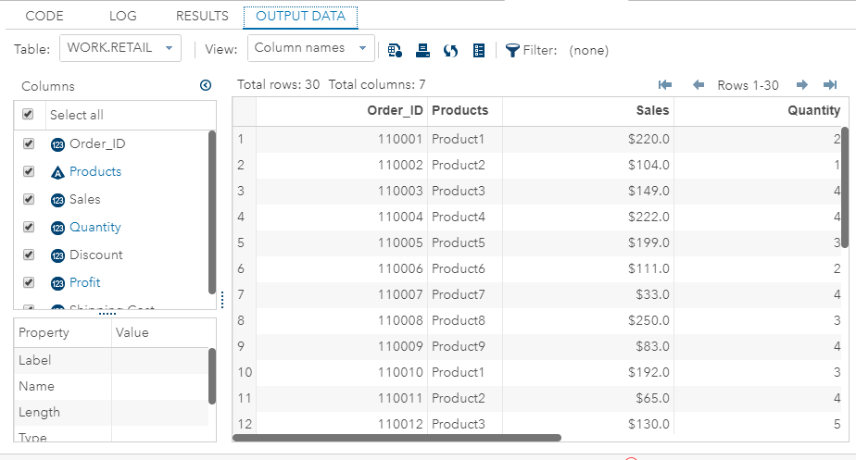

**Step2**:perform descriptive statistics for dataset

**Code**:

/*step 2: descriptive statistics */

proc means data=work.retail;

run;

OUTPUT:

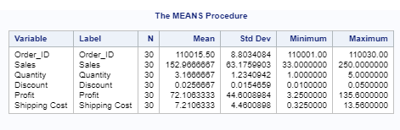

Step 3:check the significance of variables

Code:

/* Create a new variable Total_Sales = sales*quantity as sales $ value is just per unit price */

data Retail;

set Retail;

Total_Sales = sales*quantity;

run;

PROC REG DATA=Retail;

MODEL Total_Sales= Quantity Discount Profit Shipping_Cost;

run;

OUTPUT:

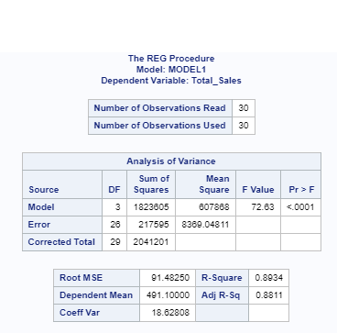

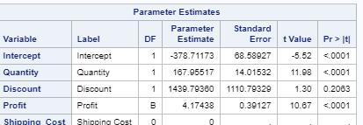

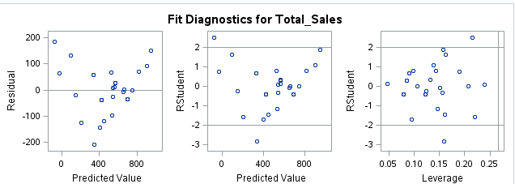

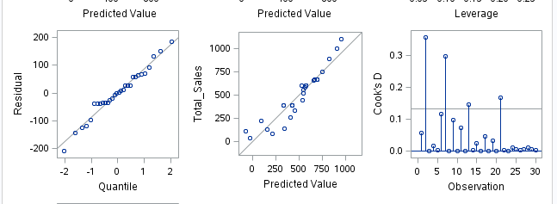

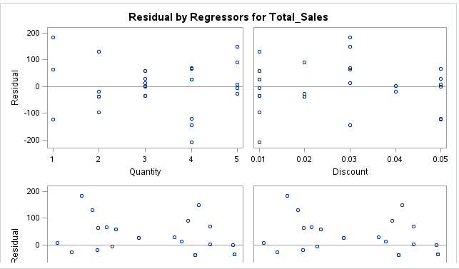

->significant variables are p<0.5 are known as significant variables.

**Step4:** Create a new data set with exponential, cube, squared, and log values for each variable

**CODE:**

/* step3:Create a new data set with exponential, cube, squared, and log values for each variable */

DATA sales_computation;

SET work.retail;

Sales_log = LOG(sales); /* log base e */

Sales_exp = EXP(sales); /* e raised to the power */

pow = 2;

Sales_sq = sales ** pow ; /* square of value*/

pow = 3;

Sales_cube = sales ** pow; /*cube of value*/

RUN;

PROC PRINT DATA=sales_computation;

VAR sales sales_log sales_exp sales_sq sales_cube;

RUN;

/* Step 4: As per result output: Since shipping cost is straight away 10% of profit across all

observations this variable (Shipping cost) should be dropped */

PROC REG DATA=Retail;

MODEL Total_Sales= Quantity Discount Profit ;

run;

OUTPUT:

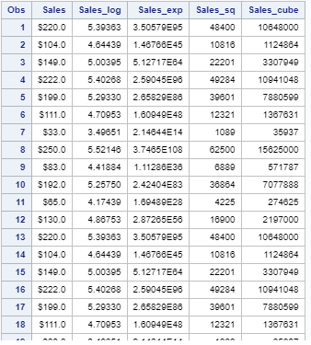

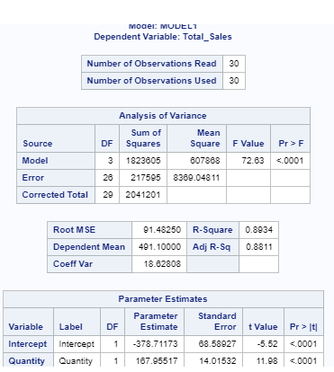

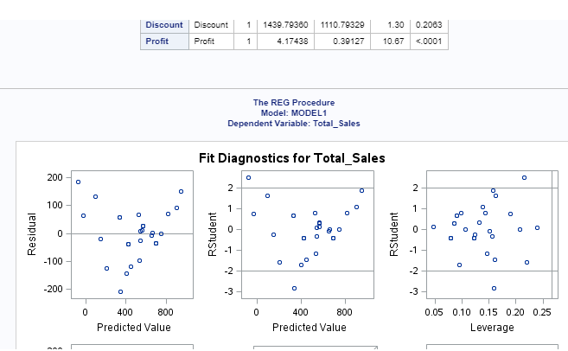

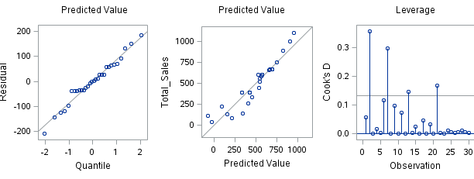

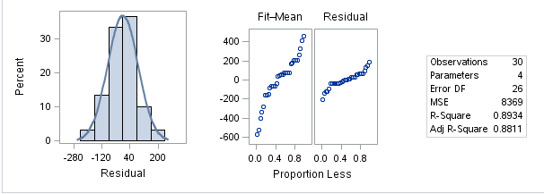

STEP5: Perform regression test

CODE:

/* Now predict total_sales and not sales */

PROC REG DATA=Retail;

MODEL Total_Sales= Quantity Discount Profit Shipping_Cost;

run;

/* As per result output: Since shipping cost is straight away 10% of profit across all

observations this variable (Shipping cost) should be dropped */

PROC REG DATA=Retail_Analysis;

MODEL Total_Sales= Quantity Discount Profit ;

run;

OUTPUT:

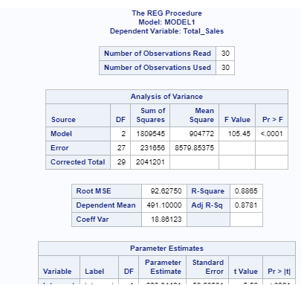

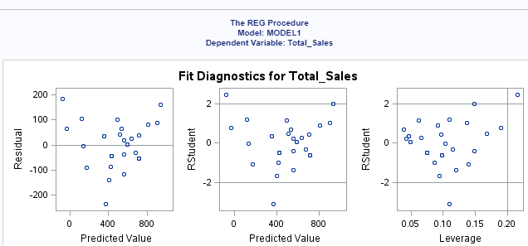

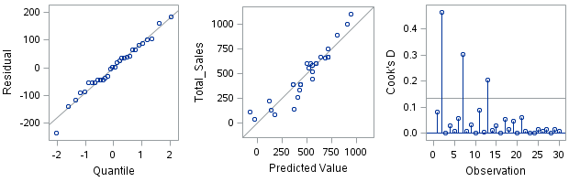

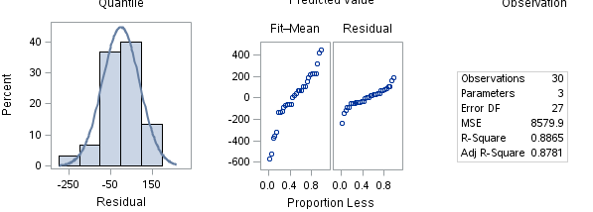

STEP6:print the output of dataset

Code:

/* You can also see the prediction in output dataset "_SalesPrediction" and compare it with

Actual Total_Sales and gauge the accuracy of model*/

PROC REG DATA=Retail;

MODEL Total_Sales= Quantity Profit ;

output out = _SalesPrediction p=Predicted_Total_Sales;

run;